 | Abdi İpekçi Caddesi Kaşıkçıoğlu Apt. No:42 D:2 34365 Nişantaşı İstanbul  www.artxist.com  info@artxist.com  T. +90 212 291 77 84 F. +90 212 343 69 35 | PRESS RELEASE

“x-ist @ INN London”

In INN London, x-ist presents brand new works of Ansen, Erkut Terliksiz, Bahadir Baruter, Ekin Saclioglu, Lale Tara, Ali Elmaci, Sena and Seda Hepsev.

In his unique hybrid works, born through an interaction of sculpture, photography and painting, Ansen transforms mundane daily objects that might otherwise escape our attention, composing new narratives with ironic commentary by active manipulation in a digital environment. “Missing Link”, the first piece of Ansen’s upcoming show “Alliance” (May, 2013 at x-ist) will be exhibited at INN London for the first time. Blended with dark humour, this work analyses the theory of evolution from the point of view of the evolutionist as well as the creationist.

Lale Tara is an artist that explores the complexity of emotions through themes of duality, timelessness and alternate realities by making use of a replica which becomes her self-representation in front of the camera. Lale Tara’s photographs are single-shot movies. She pays close attention to every detail of the set-up from the make-up of the doll to the position of the lacework on its specially designed clothing. Her subject is herself, only represented by her ‘doppelganger’ sex-doll. Lale Tara will display the first piece from her new photography series, 'Salome'. Salome is part of her upcoming show that will take place at x-ist, coinciding with the Istanbul Biennale 2013.

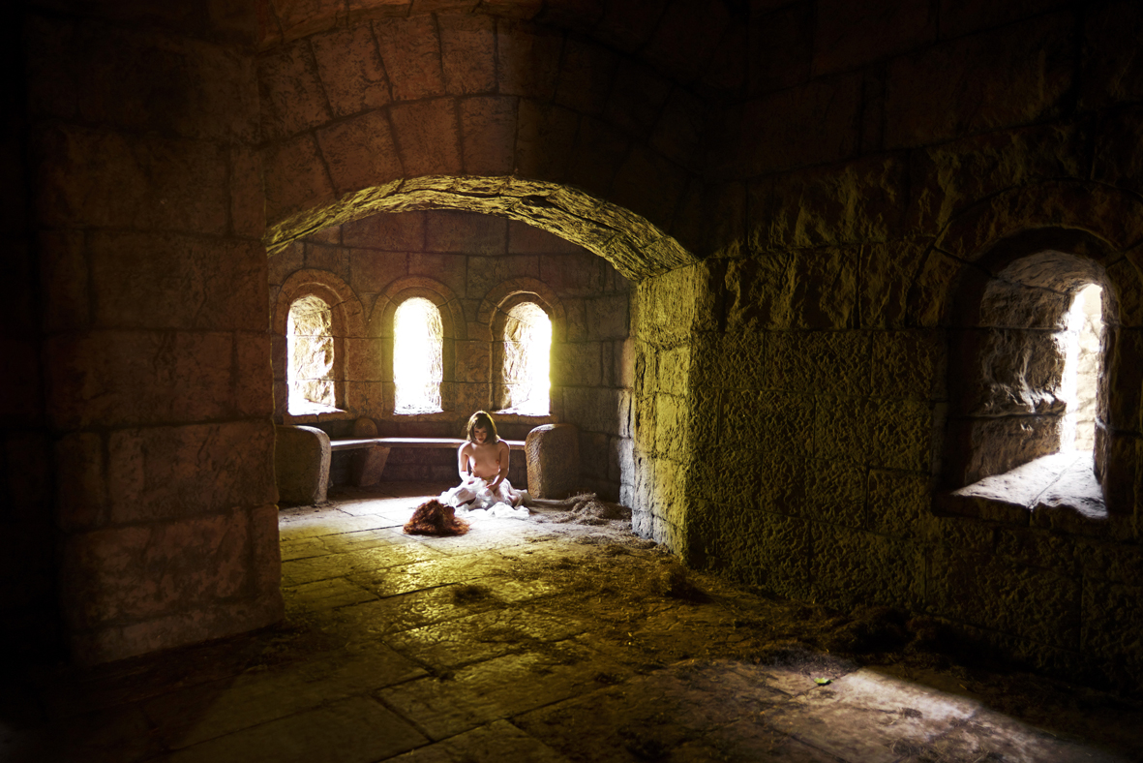

Lale Tara, Salome, Photography, ed of 3, 120 x 180 cm, 2012

Ekin Saclioglu will present a major piece “Kingdom” from her most recent show “The Pothole”. Saclioglu, who, in her previous exhibitions, questioned the reliability of memory and recollections and the relationship between dream and reality, has sometimes been inspired by a memory of her own or a story that belongs to a friend, has called attention to what is social through personal situations, builds her last exhibition on the idea of a pothole that is located on her way back home. This hole she passes by every day turns into a big hole story over time, encompassing all the holes and including both pleasant fictional realms and fears regarding reality. Ekin Saclioglu is known for her experimental material use and narrative style, and her hologramic work and stories buried in abstract and primitive figures stand out in this series.

Bahadir Baruter, a newly discovered artist with a drawing background produces digital paintings and sculptures. After his recent show “Your Family is a Lie, Dear” (2012 at x-ist), Baruter started working on this new project titled “Why Does God Allow Evil?”, questioning the business life every adult is stuck in. He views capitalism and its requirements as sacred values in modern life and questions this taboo by portraying business people in their everyday life. He also incorporates religious references and dark humour in his work. Baruter’s figures that seek eye-contact with the audience invite them for an introspective look. The first piece of his new series“Why Does God Allow Evil?” will be exhibited at INN London.

Ali Elmacı depicts the modern history of social problems without restraint when it comes to using irony and sarcasm. The aspects of family, society, state, media and sacred values, which are invisible to the naked eye are conveyed through the scenarios and characters that he builds.

Ali Elmaci presents the brand new piece “The Harem” from his series “Illustrated History of the Turks” in INN London. Making social criticisms through personal portraits, Elmaci, this time, takes in hand the power symbols in the society inspired by the harem paintings in art history. The omnipotent male figure in the middle refers to the kings of the past who owns and influences his surrounding. Elmaci will open his next solo show in Dubai in collaboration with x-ist.

Erkut Terliksiz cannot disguise himself in his expressionist paintings. He can be traced through the details of his work that combine dream and reality. Unlike life, his impression of life flows spontaneously and without plans onto his work. His journey is not bounded with rules and limitations; instead it allows freedom and amorphous figures. Terliksiz’s subconscious and memories haunt him during this only time where he can actually be solitary. His works, which seem like fiction at first but involve personal tales, are presented to the audience to let their own stories come out. We present Terliksiz’s brand new work “Time and Relative Dimension in Space” in INN London.

Seda Hepsev is a talented painter who brings an alternative approach to portraiture, pointing out to certain discrepancies in the society with the use of irony. Hepsev’s most recent work from the show “Disguise (February, 2013 at x-ist) will be presented to the London INN audience. ‘Disguise’, which means ‘to change and conceal identity’ in English, aims to question the military service that is seen as a mandatory stop towards the destination of manhood in Turkish culture, just like male circumcision and the very first sexual experience are.

The three canvas paintings originated from the movie, “Top Gun” depict the inclusion of the leading actor and his outfits into our lives in 1980s, and refresh the space that the image of an American soldier has in our memory.

Graduated from London Central Saint Martins Arts College, Graphic Arts and Design Department, SENA questions the issue of being a woman by making use of her observances and her own experiences, combining modern daily images through the use of symbols rooted in philosophy, mythology and religions. In her works, the artist breaks with established rules and rigid ideas through characters influenced by daily incidents and personal experiences. In her meticulously detailed work, women become symbols of power through their maternal abundance and fertility; they even become heroes. SENA challenges traditional stereotypes of women and presents a critical and realistic approach, a path, which leads the audience to search for universal truths stripping away their own rigid ideas, & practices and hence seeks to promote dialog and discussion.

